HTML TABLE
- A table in HTML consists of table cells inside rows and columns.
- <table> tag is used to create a table in html
- <thead> and <tbody> to represent heading section and body section of table
- Table Headers: Sometimes you want your cells to be table header cells. In those cases, use the <th> tag
- Table Rows: Each table row starts with a <tr> and ends with a </tr> tag.
- Table Cells: Each table cell is defined by a <td> and a </td> tag.

Table attribute
- border: It is used give the border to table. (<table>)
- cellpadding: It is the space between the cell edges and the cell content. (<table>)
By default, the padding is set to 0
- cellspacing: It is the space between each cell.
By default, the space is set to 2 pixels.
- colspan: It is used to merge multiple columns. (<td>)
- rowspan: It is used to merge multiple rows. (<td>)

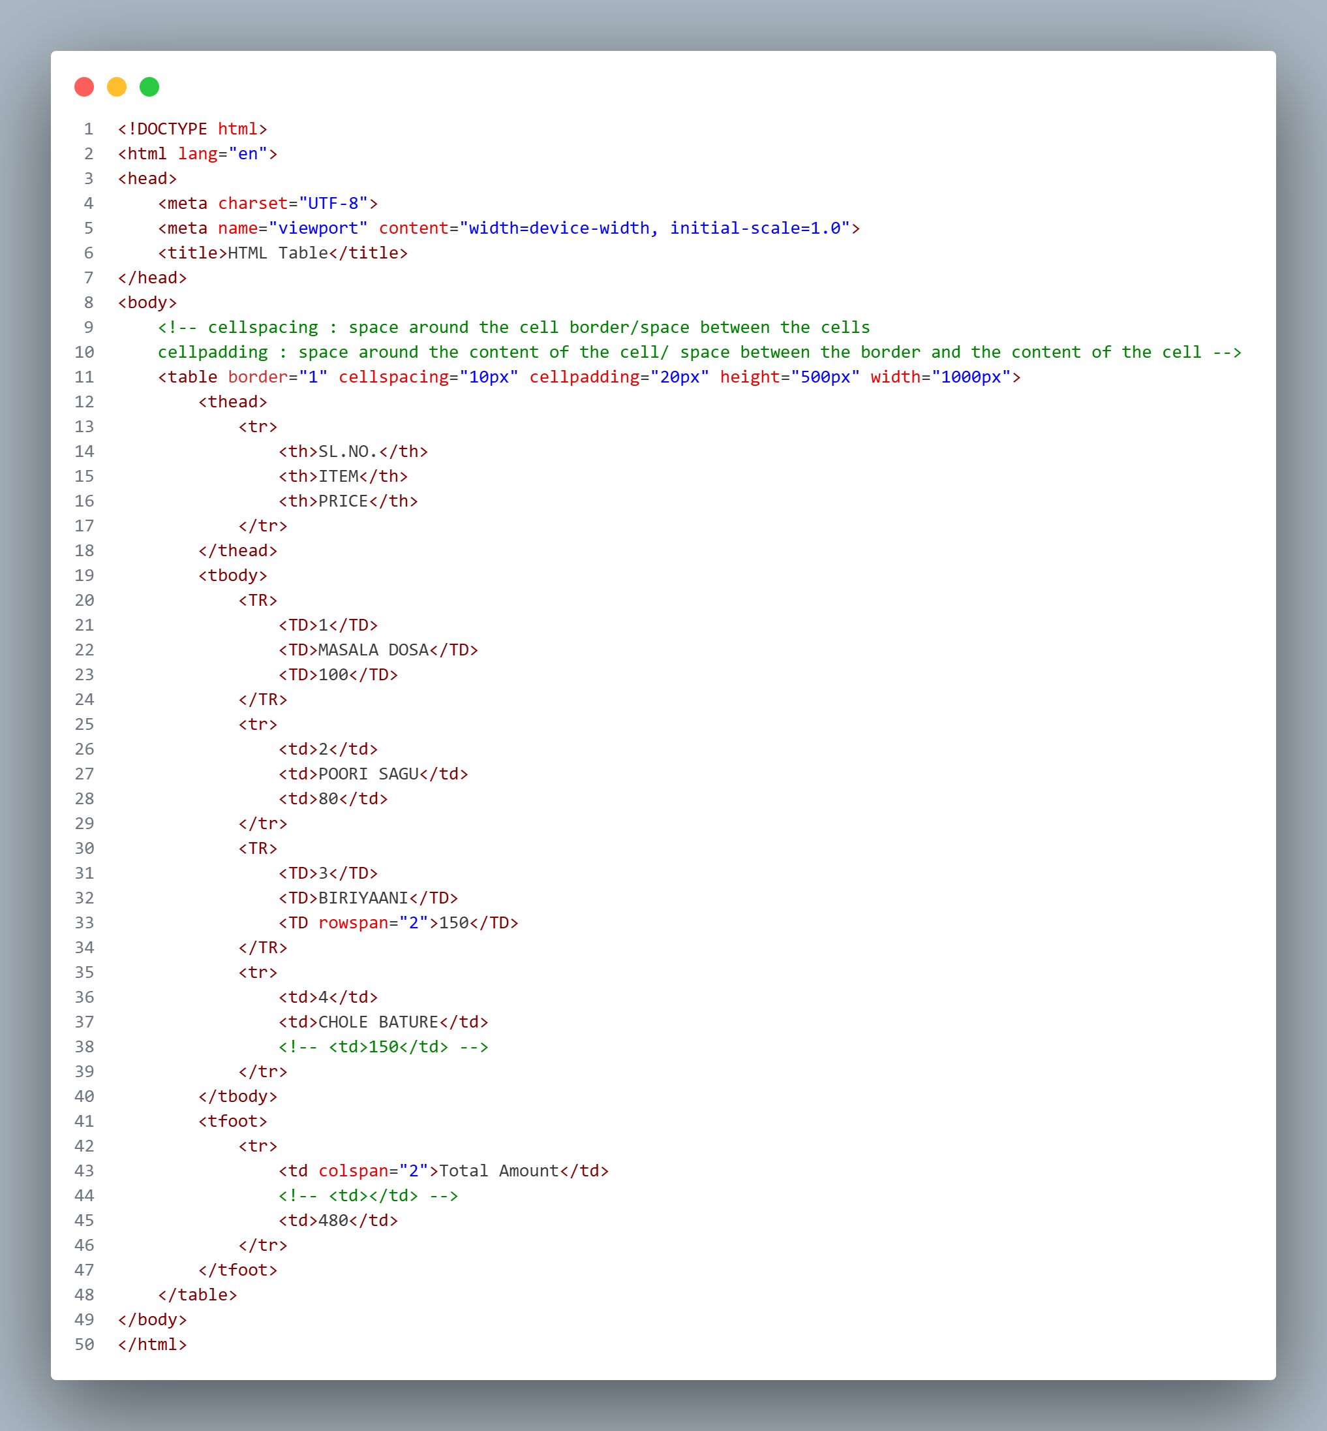

HTML FORMS
The <form> Element
- The HTML <form> element is used to create an HTML form for user input
- The <form> element is a container for different types of input elements, such as: text fields, checkboxes, radio buttons, submit buttons, etc.
- The <input> Element
- The HTML <input> element is the most used form element.
- An <input> element can be displayed in many ways, depending on the type attribute.
- Ex:
- <input type="text">Displays a single-line text input field
- <input type="password">Displays a password input field (dots will be displayed instead of the data)
- <input type="email">Displays a email input field (will give suggestion to include ‘@’ symbol)
- <input type="date">Displays a date input field (gives calendar to select the date)
- <input type="file">to get file kind of data(we can use accept attribute to represent type of file the file and we can pass .doc, .pdf, .xml)
- <input type="number"> to get number kind of data
- <input type="tel"> to get contact number, Aadhaar number kind of data
- <input type="radio">Displays a radio button (for selecting one of many choices)
- <input type="checkbox">Displays checkbox (for selecting zero or more of many choices)
- <input type="button">Displays a clickable button
- <input type="submit">Displays a submit button (for submitting the form)
- <input type="reset">Displays a reset button (for resetting the form)

- <textarea> Defines a multiline input control (text area)
- <select> Defines a drop-down list
- <option> Defines an option in a drop-down list
- <optgroup> to create dropdown with groups / Defines a group of related options in a drop-down list
- <label> Defines a label for an <input> element
- <fieldset> Groups related elements in a form
- <legend> Defines a caption for a <fieldset> element
- <button> Defines a clickable button
- <datalist> Specifies a list of pre-defined options for input controls

Form Attributes
- <form>
- Action: It defines action to be performed when the form is submitted.
- Method: It specifies the http method to be used when submitting the form data. (get-Not secured and post-Secured)
- <label>
  - for: It is used to connect label and input text field.
- <input>
  - Id: It is used to connect label and input text field and the value passed in the id attribute should be same as the value passed in the for attribute.
  - Name: The value of name attributes acts like container, The form values with name attribute will sent to a server when submitting the form.
  - Type: It represents the type of data

Form Validation Attributes
1) value: The input value attribute specifies an initial value for an input field
2) readonly: The input read only attribute specifies that an input field is read-only.
3) disabled: The input disabled attribute specifies that an input field should be disabled.
- A disabled input field is unusable and un-clickable.
4) size: The input size attribute specifies the visible width, in characters, of an input field.
- The default value for size is 20.
- Note: The size attribute works with the following input types: text, search, tel, url, email, and password.
5) Maxlength and minlength: The input maxlength attribute specifies the maximum number of characters allowed in an input field.
6) Min & Max: The input min and max attributes specify the minimum and maximum values for an input field.
7) Placeholder: The input placeholder attribute specifies a short hint that describes the expected value of an input field (a sample value or a short description of the expected format).
8) Required: The input required attribute specifies that an input field must be filled out before submitting the form.
9) Autofocus: The input autofocus attribute specifies that an input field should automatically get focus when the page loads.
10) Height & Width: The input height and width attributes specify the height and width of an <input type="image"> element.
11) List: The input list attribute refers to a <datalist> element that contains pre-defined options for an <input> element.
12) multiple: The input multiple attribute specifies that the user is allowed to enter more than one value in an input field.
The multiple attribute works with the following input types: file.

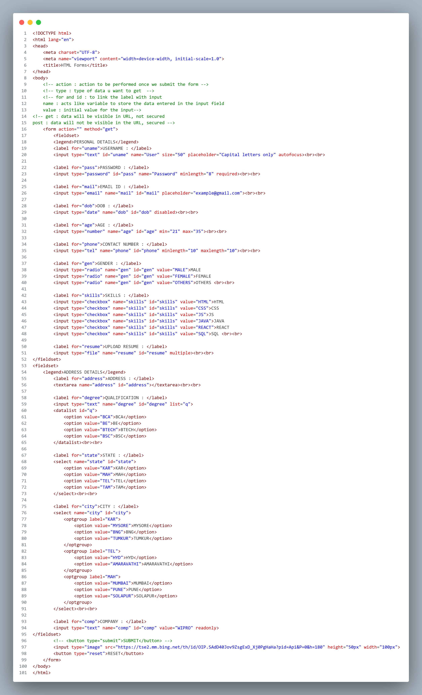

HTML MEDIA
Multimedia on the web is sound, music, videos, movies.
HTML media consist of audio, video and maps
- Audio:
  - <audio> tag is used to embed the audio into our web page.
  - The content which is written in side <audio></audio> will not display on the webpage (void element)
Attributes of audio tag:
      - src: we will pass path of audio.
      - controls: The controls attribute adds audio controls, like play, pause, and volume.
      - muted: It will mute the audio when you open your file with browser
      - autoplay: It will play the audio automatically when you open your file with browser.
      - loop: The audio will start over again, every time it is finished.
- Video :
  - <video> tag is used to embed the video into our web page.
  - The content which is written in side <video></video> will not display on the webpage
Attributes of audio tag:
  - src: we will pass path of video.
  - controls: The controls attribute adds video controls, like play, pause, and volume.
  - muted: It will mute the video when you open your file with browser
  - autoplay: It will play the video automatically when you open your file with browser.
  - loop: The video will start over again, every time it is finished.
- iframe:
  - <iframe> tag is used to embedded another document within the current HTML document.
  - An HTML iframe is used to display a web page within a web page.
  - The HTML <iframe> tag specifies an inline frame.
  - Height and width attributes are used to specify the height and width of th iframe
  - Title attribute is used to give the title for the iframe

